Data analyst portfolio project (Pizza sales analysis)

PIZZA Sales SQL Queries

1. KPIs
2. Total Revenue

SELECT sum(total_price) AS Total_Revenue FROM projects.pizza_sales;

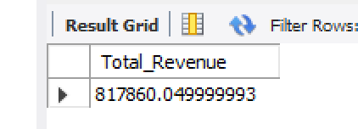

1. Average Order Value

SELECT sum(total_price)/count(distinct order_id) AS Avg_order_value from projects.pizza_sales

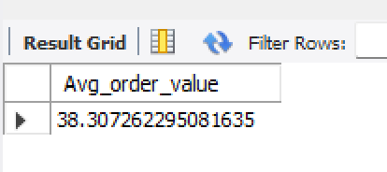

1. Total Pizza sold

SELECT sum(quantity) AS Total_pizza_sold from projects.pizza_sales;

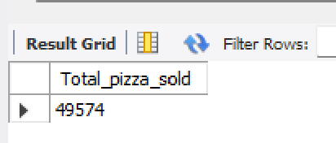

1. Total orders

SELECT count(distinct order_id) AS Total_orders from projects.pizza_sales;

1. Average Pizzas per order

SELECT cast(sum(quantity)/count(distinct order_id) as decimal (10,2)) from projects.pizza_sales;

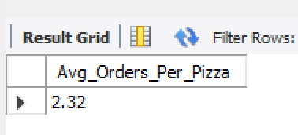

CHARTS REQUIREMENTS

1. Daily Trend For total orders

SET sql_safe_updates = 0;

UPDATE pizza_sales

SET order_date = STR_TO_DATE(order_date, '%d-%m-%Y') -- assuming format is 'DD-MM-YYYY'

WHERE STR_TO_DATE(order_date, '%d-%m-%Y') IS NOT NULL;

ALTER TABLE pizza_sales

MODIFY COLUMN order_date DATE;

SELECT dayname(order_date) AS Month_name, count(distinct order_id) AS Total_Orders

from projects.pizza_sales

group by dayname(order_date)

1. Monthly Trend For total orders

SELECT monthname(order_date) AS Month_name, count(distinct order_id) AS Total_orders

from projects.pizza_sales

group by monthname(order_date)

ORDER BY Total_orders DESC

1. Percentage of sales by Pizza category

SELECT pizza_category,sum(total_price) AS Total_sales, SUM(total_price) *100 /

(SELECT SUM(total_price) FROM pizza_sales where month(order_date) = 1) AS percentage_of_Sales

FROM pizza_sales

where month(order_date) = 1

Group by pizza_category

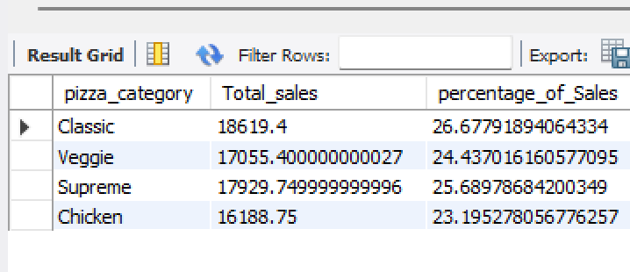

1. Percentage of sales by Pizza size

SELECT pizza_size, CAST(sum(total_price) AS DECIMAL (10,2)) AS Total_sales, CAST(SUM(total_price) *100 /

(SELECT SUM(total_price) FROM pizza_sales WHERE quarter(order_date)=1) AS DECIMAL (10,2)) AS percentage_of_Sales

FROM pizza_sales

WHERE quarter(order_date)=1

Group by pizza_size

ORDER BY percentage_of_Sales DESC

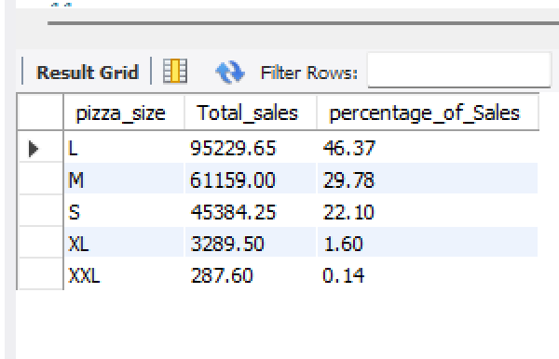

1. Total pizzas sold by pizza category

SELECT pizza_category, sum(quantity) AS Total_quantity_sold

from pizza_sales

where MONTH(order_date)=3

GROUP BY pizza_category

order by Total_quantity_sold desc

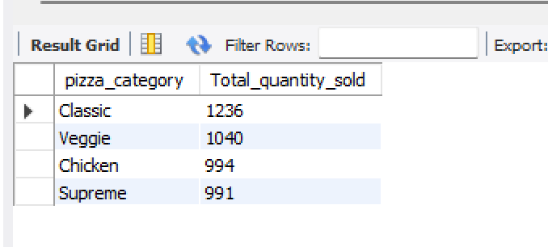

1. Top 5 best sellers by revenue, Total quantity and total orders
2. SELECT pizza_name, sum(total_price) AS Total_revenue

from pizza_sales

GROUP BY pizza_name

order by Total_revenue DESC

LIMIT 5;

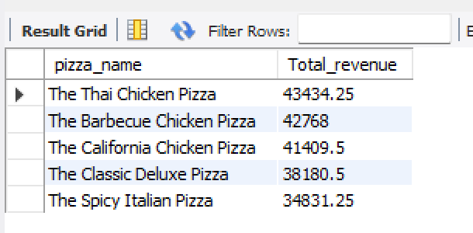

1. Quantity

SELECT pizza_name, sum(quantity) AS Total_quantity

from pizza_sales

GROUP BY pizza_name

order by Total_quantity desc

LIMIT 5;

1. Orders

SELECT pizza_name, count(distinct order_id) AS Total_orders

from pizza_sales

GROUP BY pizza_name

order by Total_orders desc

LIMIT 5;

1. Bottom 5 worst sellers by revenue, Total quantity and total orders

SELECT pizza_name, sum(total_price) AS Total_revenue

from pizza_sales

GROUP BY pizza_name

order by Total_revenue asc

LIMIT 5;

SELECT pizza_name, sum(quantity) AS Total_quantity

from pizza_sales

GROUP BY pizza_name

order by Total_quantity asc

LIMIT 5;

SELECT pizza_name, count(distinct order_id) AS Total_orders

from pizza_sales

GROUP BY pizza_name

order by Total_orders asc

LIMIT 5;

